Teaching Plan
课型：Grammar
教学内容：Subjunctive Mood--Unreal if clauses
执教者：陈虹宇

- The analysis of the content:
This teaching period mainly deals with the grammar：the subjunctive mood. In the English language verbs are often divided into three different moods—the indicative mood，the imperative mood and the subjunctive mood.The indicative mood is used to indicate a fact or put forward a viewpoint.The imperative mood is used to express direct commands or requests. It tells you to do something. It is also used to signal a prohibition，permission or any other kind of exhortation.The subjunctive mood is used to express a condition which is doubtful or not factual. It is most often found in a clause beginning with the word “if”. So the command of unreal if clauses conditions is very important in the learning of subjunctive mood. And in this period we will focus on only part of the usages of the subjunctive mood，that is，the subjunctive mood beginning with the word “if”．
- Teaching aims:
I. Three-dimensional targets:
1) Language knowledge and skills
After the class, students will learn three conditions of Subjunctive Mood in if clauses, and how to use them..
2)Process and methods
A. By sentence study, students discover when to use unreal if clauses and the three conditions of it.
B. By discussing, students learn to analyze when to use unreal if clauses and three conditions of it.
C. By practice and evaluation, students learn to make sentences and express themselves freely by using unreal if clauses.
3) Affective attitudes
By practice, students are encouraged to learn to cooperate with others. Meanwhile, students are helped to have active and positive attitudes towards English learning.
II. Key points:
1) Enable the students to learn how to write sentences using unreal if clauses.
2) Improve the students’ comprehensive language study ability.
III. Difficult points:
Discover three conditions of unreal if clauses, and how to use it.
3. Teaching methods
Task-based Approach, case study
4. Teaching aids
A computer and PowerPoint.
Teaching procedures: | Focuses , reasons, or expected results
Step I Warming-up (1min)  T: Before today’s class, I’d like to share a beautiful song with you, let’s enjoy it together. Have you noticed some sentences in this song? Now please look at these sentences.  T: If I were a boy , even just for a day , I’d drink beer with the guys and chase after girls …If I were a boy , I think I could understand how it feels to love a girl . I swear I'd be a better man …  T: However, we all know the singer (Beyonce) is a girl,right? So my question is: Do you think these sentences are correct?  Step II lead-in ( 2mins)  T: Here I’ll give you more examples, please compare and find the difference. So from these examples, we can see what is subjunctive mood.  T: Subjunctive mood is used to talk about situations that are not true or not likely to become true.  Step III Aim （1min）  After today’s class, you will be able to:  - Master three conditions of unreal if clauses;  - Use it freely in exercise.  Step III Study and discover( 7mins)  Act1: Teacher leads students in studying Situation One.  Step1: find out the rules  T: now please think about this question, What would you do if you were a boy / a girl?  If I were a man, I would be a good husband.  If I were a husband, I would train my kid to love homework.  If I were a husband, I would train my wife to love housework.  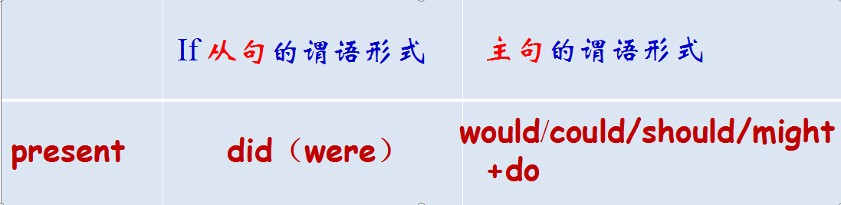  T: This three sentences are all if clauses, and they are unreal if clauses, because the are contrary to the fact. More specifically, they are all in the conditions which are contrary to the present. Because I’m not a boy now, I’m a girl, right? So can you summrize the rules by yourselves?  Step2: practice  Make sentences by using Subjunctive Mood. When you hear the first sentence, you make a sentence after the second half of the first sentence.  Act2: Teacher leads students in studying Situation One.  Step1: find out the rules  T: Have you ever seen this film? After jack met rose in Titanic, he made a confession to rose, he said, “If I____________the ticket,  I ________________ on board. If I____________ on board,  I_______________you.  T: so we can see clearly that these sentences are all contrary to the past. And the conclusion should be:  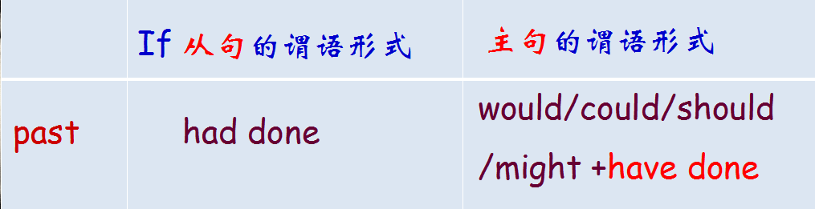  Step2: practice  Making sentences by using unreal if clauses.  Act3: Teacher leads students in studying Situation One.  Step1: find out the rules  T: just now we know that jack and rose fell in love with each other, but later, the titanic hit the iceberg and they all fell into the cold water, and before jack died, he said to rose,  If I____________, I_________you some day.  If we_______ , we__________many children in the future.  If we_________many children, I_________them our love story.  T: so here we can see jack made an assumption to their future, which will not exist. So the conclusion should be:  Step2: practice  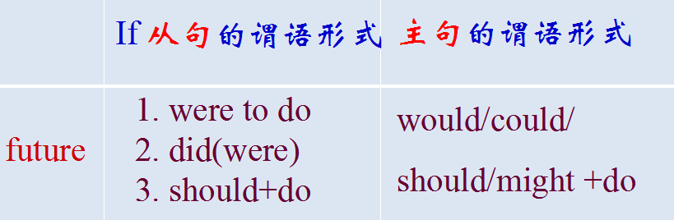  Making sentences by using unreal if clauses.  Step IV Summary (1min)  Step V Consolidation (2mins)  Step VI Appreciate a poem “if time... (1min)  Guide ss to appreciate a poem and teach ss to cherish time.  Step VII Assignment  Write a short passage “ a regretful thing by using unreal if clauses.  The design of blackboard:  Grammar: Subjunctive Mood  --Unreal if clauses  unreal if clauses  - The defination of Subjunctive Mood  2.Three  conditions  - Present  - Past  - Future  从句 主句  did(were)  had done  did  should do  were to do  Would/could/should/might+do  Would have done  would do | Focus:  To arouse the interest by playing a song and help students know what Subjunctive Mood is.  Focus:  Through observation, students will know what Subjunctive Mood is.  Focus:  To get students to know what they are going to learn in today’s lesson.  Focus:  1. To discover when to use Subjunctive mood and its three conditions.  2. To learn to sum up the rule of a Grammar by case study.  Focus:  - To practice the structures in a relaxing way.  - To try to make sentences using if clauses.  Focus:  To practice using Subjunctive Mood in a situation.  Focus:  - To practice the structures in a relaxing way.  - To try to make sentences using if clauses.  Focus: To summarize what they have learnt.  Focus: To help students consolidate what they have learnt in a more interesting way.  .
Reflections: The class is well prepared, and the procedures are well designed. The three conditions of if clauses are shown clearly. In a word, the effect is up to my expectations.

