**翻转课堂之同位语从句**

**1. Analysis of teaching content and students’ learning situation：**

首先，对于同位语这一概念的了解，在平时的阅读讲解以及语言点造句中对于这一概念有所渗透，但是对于同位语从句这一概念学生们较为陌生。因此，区分同位语与同位语从句是本节课的一个目标；对于同位语从句的深入了解将贯穿本节课的始终。

其次，名词性从句为必修三最重要的语法点，其中宾语从句，表语从句以及主语从句在unit2-4中着重学习过，尤其是对于其中连接词的学习较为深入。因此学生对于unit5中本节课同位语从句的连接词的使用会较为容易。

第三，对于语法学习，大多数同学表示出倦怠，并且认为同位语从句不重要，考试不考。这一观念需要被纠正，同时本节课将通过竞赛环节让同学们在竞争中体会到语法学习的趣味性，并且重视英语学习中的点滴积累。

第四，所带班级学生两极分化较大，因此在知识的呈现以及任务的理解上小组呈现，小组互助的形式能有所帮助；并且由于两极分化大，因此在任务的设计，以及作业的布置上也进行分层任务、分层作业的设置。

**2.Teaching Aims:**

*Knowledge aims:*

The students can understand the usage of appositive clause and get the sentence structure and its meaning of each sentence, and can induct the rules of the functions of grammar.

*Ability aims:*

The students can identify the appositive clause, and can use this kind of clause into their writing or speaking.

*Emotional aims:*

The students can foster the interest and desire of learning English grammar and cooperate with other group members actively to complete the tasks together.

After watching the speech ***I Have a Dream*** and making the sentences ‘“I have a dream” that…’the students can be encouraged and never give up their dream.

**3.Teaching Key Points:**

Get the sentence structure and identify the appositive clause in different situations according to the features of Appositive Clause.

Use the correct connectives and use the appositive clause in proper situations.

**4.Teaching Difficult Points:**

Help students identify the appositive clause in different situations according to the features of Appositive Clause.

**5.Teaching Methods:**

Inductive Method, Task-based Teaching Method

**6.Teaching Aids:** Focusky, video

**7.Teaching Procedures:**

**Step 1 Lead in**

Share My Love Story and ask the students what kind of grammatical phenomenon they can find.

*Jack, my husband, is a very romantic man. Our wedding anniversary, May 8th, is a special day for us. He prepared a gift, a new watch, to show his love to me.*

**Step 2 Presentation**

1. Introduce the concept of appositive. 同位语成分是对其前面的名词或代词进行解释和说明.
2. Show 2 sentences and ask students to the compare them to find out the differences.

*We got a plan, going to Beijing on Sunday.*

*We got a plan that we would go to Beijing on Sunday.*

3.Summarize the appositive clause and the structure of it

抽象名词+连接词+从句

Abstract nouns：fact, idea, thought, doubt, news, hope, truth, belief, promise, word , wish, opinion, question, problem, truth, decision, conclusion, suggestion, advice, plan …

Connectives：that,whether,what,who,when,where,why,how

4. Show the following sentences lead them to have a better understanding of the different connectives of appositive clause.

1. 连接词that引导的同位语从句

We Chinese people strongly hold the belief that Diaoyu Islands belong to China. that在同位语从句中不做成分,无意义，只起连接作用,不可以省略.

1. 连接词whether引导的同位语从句

The problem whether the conclusion is right hasn’t been proved.

同位语从句表示一般疑问句语意“是否”，连接词用whether,不用if.

(3.连接代词what/which/who

The question who should go abroad hasn’t been decided yet.

谁会出国这个问题还未决定.

I have no idea which one I should choose.我不知道该选哪个.

I have no idea what he likes.我不知道他喜欢什么。

同位语从句为特殊疑问句语意，连接词选择根据句意。

连接代词在从句中充当成分，有意义，不可省略。

(4. 连接副词why/where/when/how

(1) The question when/where we should set off has not been decided.

(2) I have no idea when /why/whether they left.

(3) There is a problem how we can make full use of time.

连接副词在从句中充当状语，有一定意义，表示“为什么、何地、何时、怎样 ”之意。

**Summary:**

陈述时一般用that引导，并且that不可以省略；如果从句含有一般疑问的语意则用whether引导；如果为特殊语意的连接词的选择应该根据句意。总之，缺什么意思填什么连接词。不缺成分不缺意思that引导。

**Step 3 Practice and competition**

Competition：divide the students into 6 groups to compete to finish the 4 tasks.

Task 1: Fill in the blank（每个5分，共20分)

Task 2.Correct the mistakes(10分)

Task 3. Rewrite the two sentences into an Appositive Clause . （20分）

Task 4: Translate the sentence（10分）

After the competition, let the students watch a speech ***I Have a Dream*** and making the sentences ‘“I have a dream” that…’which also aims to encourage students to stick to their dream.

**Step 4. Summary and homework**

Summary.

(1.definition(定义): the appositive and the appositive clause.

---show or explain the meaning of the noun.

Structure(结构): 抽象名词+连接词+从句

(2. the connectives 连接词

(3.Practice and competition

**Homework:分层作业**

**Level 1: Write down the sentences and complete the story.**

I got a problem that I lost the new watch. I have no idea _______________________（我是在什么地方和什么时候丢了它). Yesterday, Jack asked me a question ___________________（为什么我不戴着它）. If I told him the truth that I lost it, _______________（毫无疑问）that he will be angry. What should I do?

（我的朋友得知消息）______________________ that I lost the new watch. She gave me a suggestion ___________________________（我应该告诉Jack实情）.

I didn’t want to lie to my husband. （因此我给他发了一条信息）_____________________that I lost the watch.

He finally forgave me. I made a promise __________________________（我以后将会更加细心）.

**Level 2: Make your own sentences.**

1. I have a dream that…

2.We heard the news that…

3.There is no doubt that…

4. We have an idea/the thought/ the hope that...

5. We’ll discuss the problem how/ when/ where…

**8. Blackboard Design:**

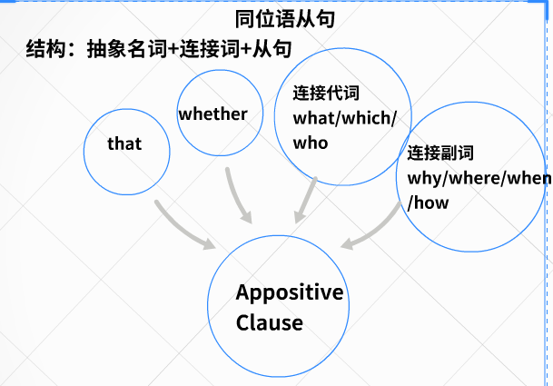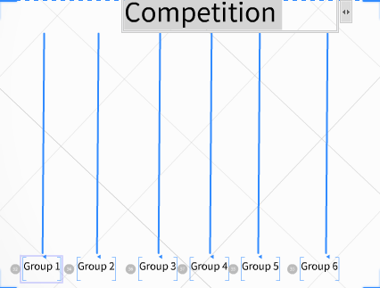

**9.Teaching Reflection:**

Production 部分由于时间原因，安排到了competition环节homework中输出，未能将这一部分完成充分呈现为本节课的不足。

that是个常见词的引导词,可以引导不同种类的从句, 用法比较复杂,尤其是在引导定语从句和同位语从句的区别，学生在学习过程中容易混淆他们的用法,加剧分析句子的困难。因此不足在于本节课中对于that的用法讲解弱化了，练习也不足；为在有限的时间内突出重难点，让学生们先直观的理解同位语从句；将易混淆点同位语从句与定语从句的区别没有进行区分，实属遗憾，也恳请各位评委老师给予相关的建议。